NIServer SDD
Background
NIServer is a server that provides user tracking service for clients through TCP socket. This makes things much simpler for client as they don’t have to care about the sensor and relevant SDK anymore. What they need to do is to simply ask for data and use it.

Working flow
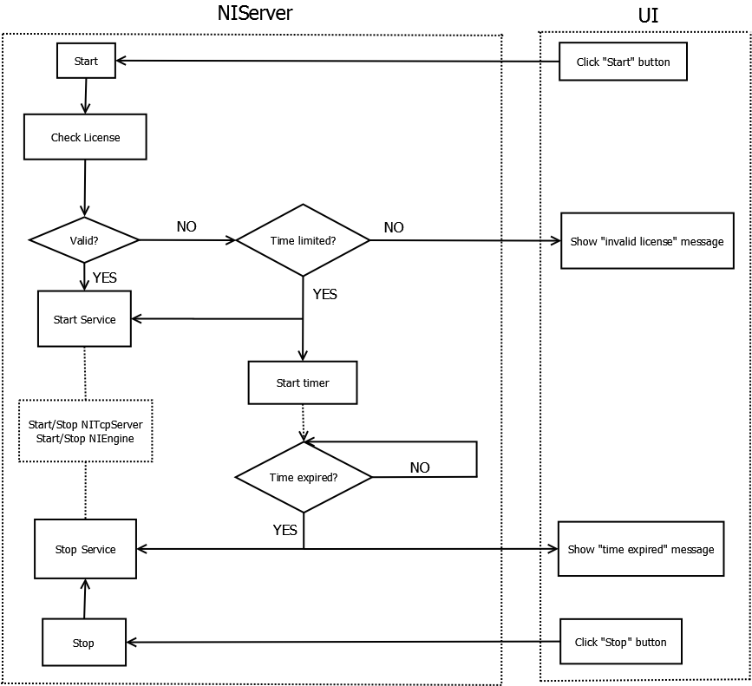

Components
UI – Qt based interface for visual operation.

NIServer - the headquarter, is responsible for:
- Check license
- Start/Stop service
- Report status to web server

NIEngine – the OpenNI interface, is responsible for:
- Turn on/off the sensor
- Read skeleton data
A dedicated thread is created for data reading.
TinyThread++, a portable thread implementation is used. More info here: http://tinythreadpp.bitsnbites.eu/

- Detect gestures
- Filter Joints’ noise
Using one euro filter, a simple speed-based Low-pass filter.
More info here: http://www.lifl.fr/~casiez/1euro/

NITcpServer – the TCP socket server, is responsible for:
- Create QTcpServer – Listening and accepting incoming connections from client.
- Create QTcpSocket – Represent an established TCP connection, through which streams of data are transferred.
- Parse the command – parse the command from client following preset simple protocol, than ask for the relevant data from NIEngine.
- Answers the client – sending back parsed result.

Utils – provides convenient tools
- Logger
Saving log info to file
- Jason parser
Using vjason, a destructive parser. More info here: http://code.google.com/p/vjson/
- Http request
Using libcurl, an easy-to-use client-side URL transfer library.
More info here: http://curl.haxx.se/libcurl/
- Xml parser
Using expat, an XML parser library written in C.
It is a stream-oriented parser in which an application registers handlers for things the parser might find in the XML document (like start tags). More info here: http://expat.sourceforge.net/

Notes
QtCreator can’t include file which has space in its directory (e.g., “C:\Program file”), we copy OpenNI’s include folder and openni.lib to source directory to avoid this problem.
Terminology
Pink – Pure C/C++ implementation
Green – Qt bound implementation

Build & Run
- Install QtCreator 2.5
- Install Qt 4.8
- Install OpenNI 20.4.2.20
- Build NIServer
- Copy runtime library and data(will be done automatically later)
- Run NIServer.exe

History
2012-11-15 by Len Zhong Initial draft aligned with commit today.

